**SuperLite Large Fit Protocol**

**I. Overview**

A. Study objective: Gather measurements of face dimensions to inform parameters for a size large SuperLite frame

B. Sample size requirements:

* 12-20 subjects
* Large heads
* Male and female (does not need to be equally distributed)
* Large non-Asian, and Large Asian subjects (equal distribution)

C. Equipment needed

* Calipers
* Measuring tape
* Pupilometer
* SuperLite frames

D. Desired measurements:

* Ethnicity
* Gender
* Head circumference
* Optical Enginte Tip to Tip (OETT) top (above stem) and bottom (below stem)
* Interpupillary distances (IPD, left, and right)
* Left and right side view pictures of fit, Front facing picture of fit

E. Large heads are defined as a circumference of 59cm and above (see table for standard bike helmet sizes below):

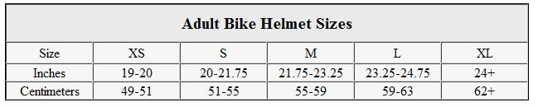

**II. Procedures**

1. Seat subject and go over test procedures.
2. Record the subject’s ethnicity and gender.
3. Measure and record the subject’s head circumference, taking care to measure from ~1inch above the brow to the peak of the occipital bone:  
   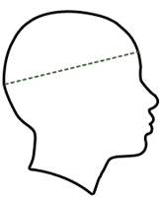
4. Measure and record the interpupillary distances of the subject. Have the subject hold the pupilometer and look at the green light. Align the markers with the center of each pupil individually.
5. Have the subject carefully put on the frames. Take a picture of the fit both the left and right sides, taking care to show fit at the temples:

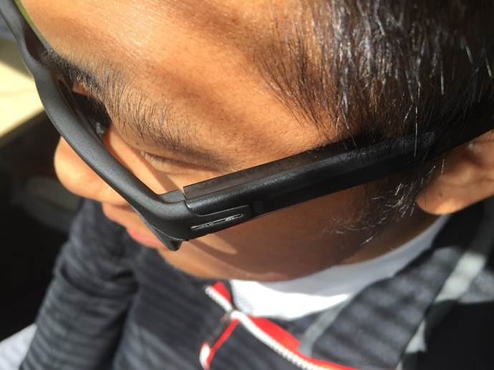  
  
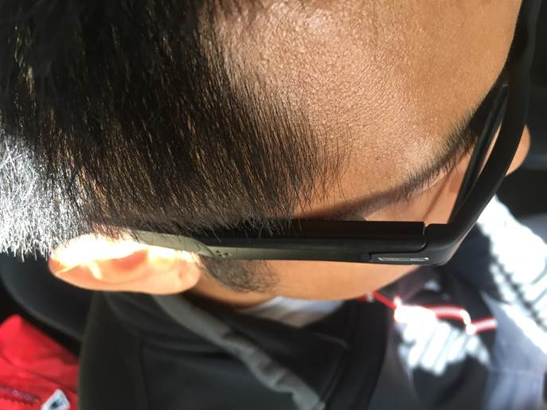

1. Take a picture of the fit from the front.
2. Using the calipers, measure the OETT above the stem. The OETT is depicted below:  
   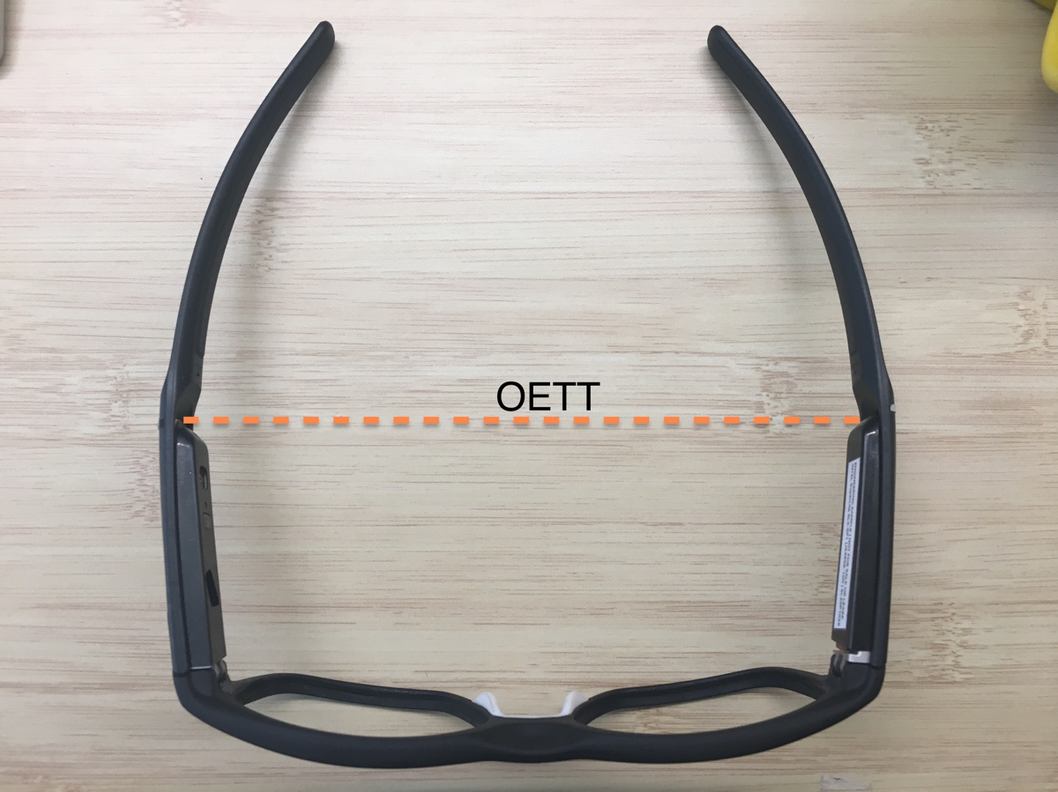  
     
   Remove the calipers and ask subject to keep the glasses on. Use a ruler to measure the distance between the two caliper tips. Record measurement
3. Repeat the caliper measurement and record for the OETT below the stem.